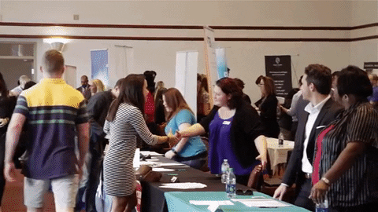
Exhibit at the LIVE 78th OSMS CME Conference
Hello Future Exhibitors!
Come flaunt your products and company name at our annual CME Conference, which boasts an average of 500 medical providers from Utah and across the country.
May 16-19, 2023, Ogden Surgical-Medical Society will host our 78th Annual CME Conference: Lifestyle Medicine in Primary and Specialty Care 2023 on the 3rd floor of the Shepherd Union building at Weber State University in Ogden, Utah.
REGISTER
We offer a variety of options for exhibitors to participate. More details can be found below in the “Agreement Form,” but the categories are: purchasing an exhibit space, sponsoring a breakfast, lunch, or break, or sponsoring a speaker at the conference. Exhibitor tables are arranged by the order payments are received.
Past vendors have told us this is the best event they go to each year to engage busy clinicians in meaningful discussions about products and services. This includes well known, and groundbreaking technology and medications.
I’m excited to work with you at this year’s conference. For any questions, or special proposal needs, please contact me at 801-546-5585 or email me at teresapuskedra@ogdensurgical.com.

Looking forward to hearing from you,
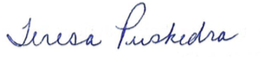
Teresa Puskedra
Executive Director
Ogden Surgical-Medical Society

P.S. Your participation as an exhibitor includes:
- One banquet table that is six-foot in length and 30-inches deep, unskirted, and a maximum limit of two exhibitors behind each table.
- Dedicated time for attendees to visit exhibitors. Breaks are included daily from 9:30 a.m. to 10:00 a.m. and 2:00 p.m. to 2:30 p.m.
- Increased provider attendee engagement through the conference app EventMobi. Provide a question about your organization that you would like the providers to ask and watch as they flock to you.
  - Email your question by April 1, 2023, to teresapuskedra@ogdensurgical.com. Questions can be added to the app up to the first day of the conference.
- Free Social and Dinner to mingle with providers on Tuesday, May 16, 2023, at 5:30 p.m. This is available for you and your spouse as well as any of your counterparts and their spouses in your organization. The amount attending the social from your company and if that includes the dinner is due by April 1, 2023, for food ordering counts. The social is 5:30 PM to 6:30 PM and the Dinner is 6:30 PM to 8:30 PM.
- Free breakfast, lunch, and breaks included with exhibit table payment.
- Free attendance at all the lectures (excluding skill labs and CME credit).

Sponsor and Exhibitor Agreement Form (download)
Ogden Surgical-Medical Society
78th CME Conference
May 16, 17, 18, 19, 2023
DOWNLOAD FORM

